Setup class library –

REVERSE ENGINEERING

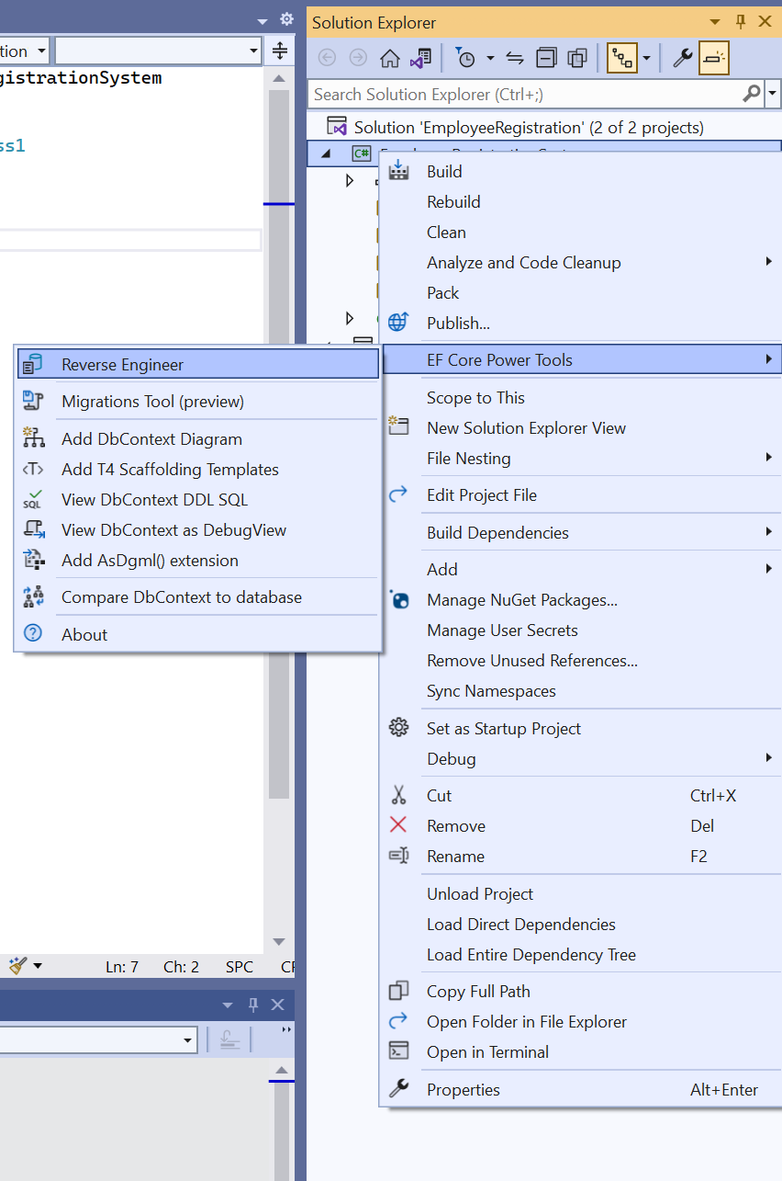

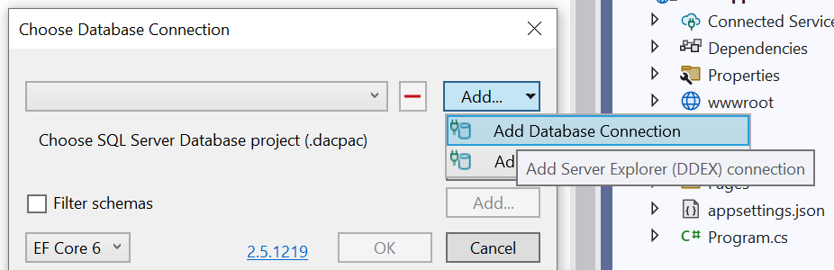

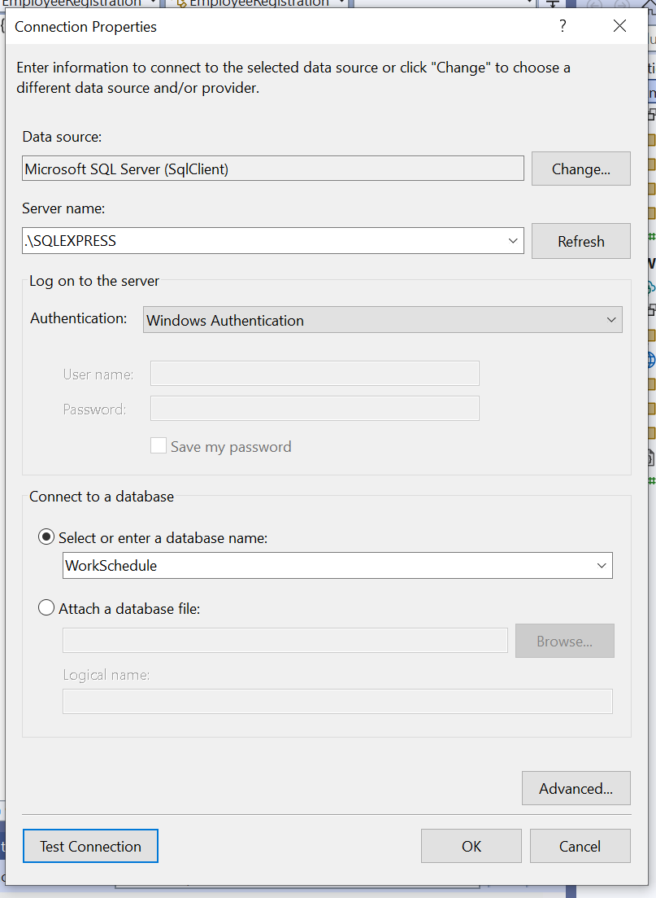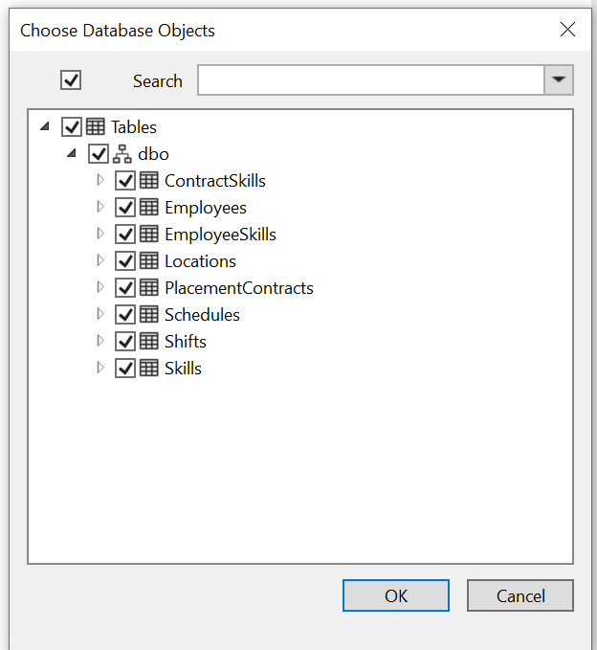

Press Ok AND SELECT THE REQUIRED TABLES

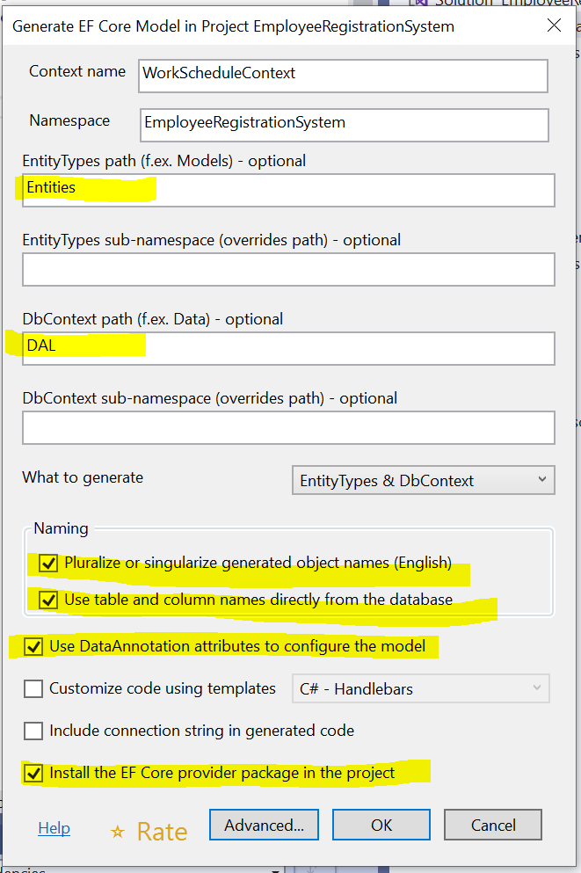

Add dependencies

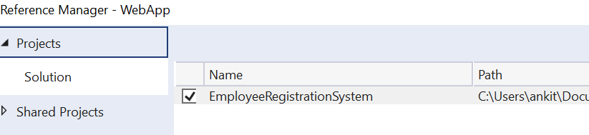

Manual reverse engineering

Install-Package Microsoft.EntityFrameworkCore.Tools

Scaffold-DbContext 'Data Source=.\SQLEXPRESS;Initial Catalog=Chinook;Integrated Security=True' Microsoft.EntityFrameworkCore.SqlServer -o Entities

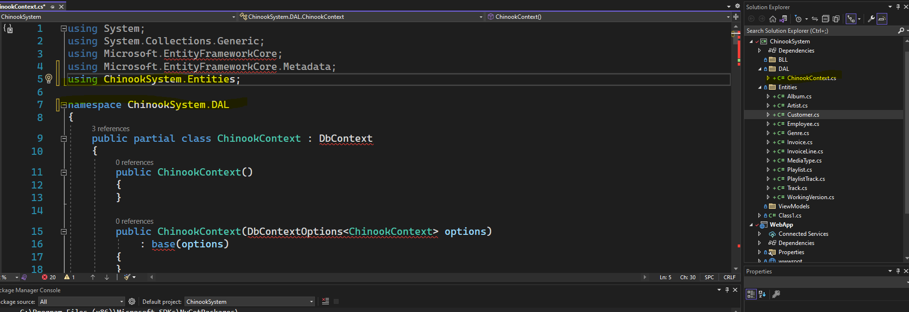

Manage Nuget package

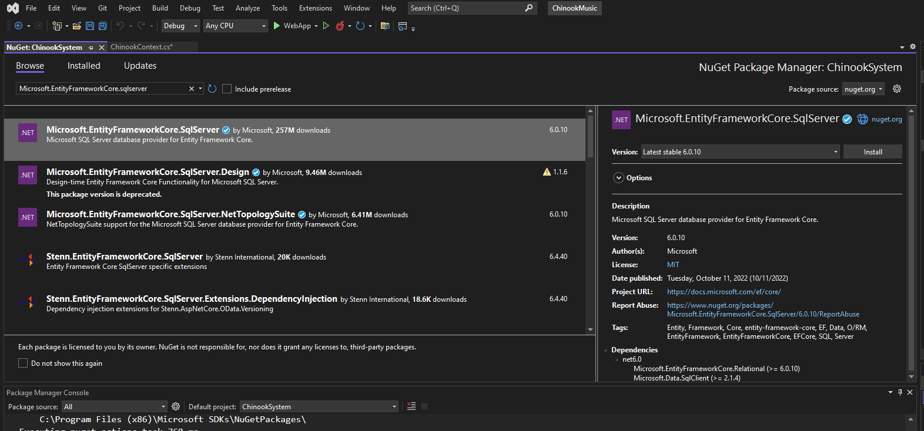

Should have following two packages

If not then make sure following

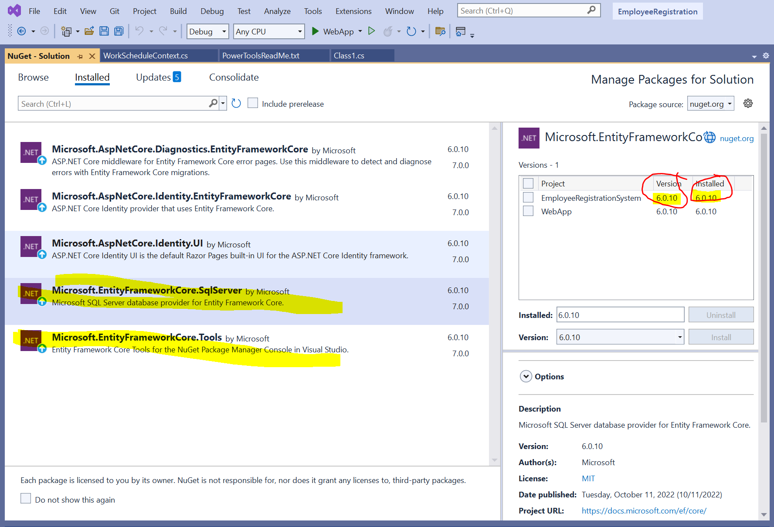

Not 6.0.10 need to update

Rebuild solution

Should have following file in DAL

Add class now

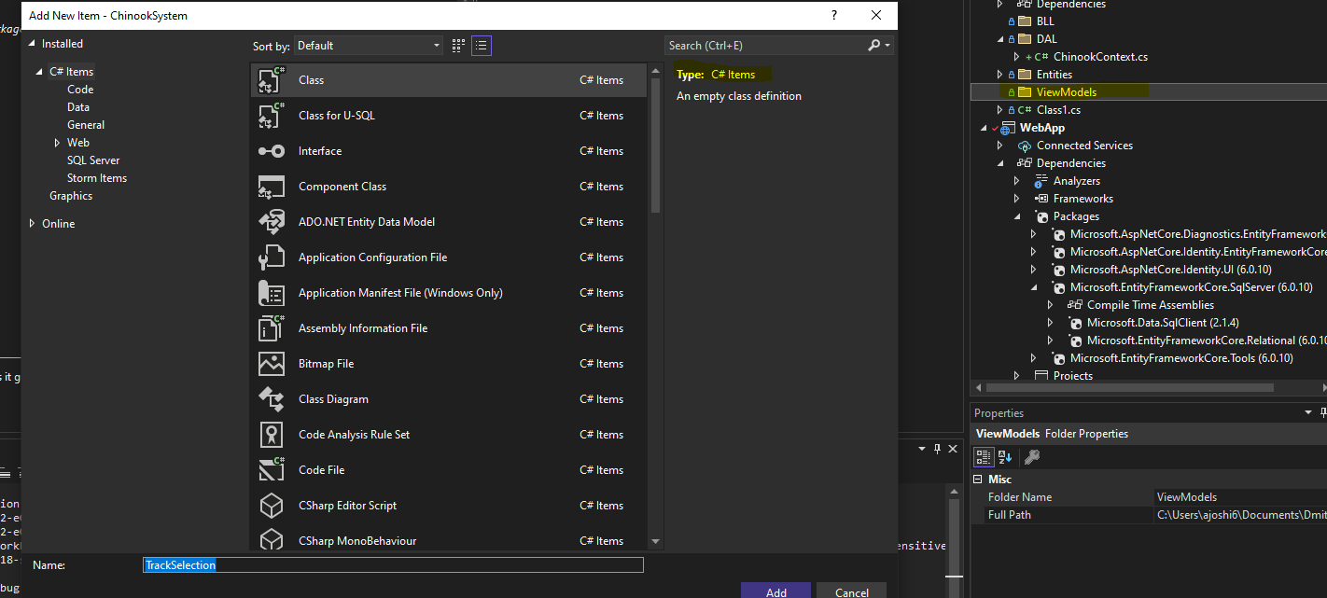

Add other model class PlaylistTrackInfo, and PlaylistTrackTRX

Now, we should have query and command model.

Make context and entities class internal if its public

Bootstrap is long. Delete it and replace it with jquery.

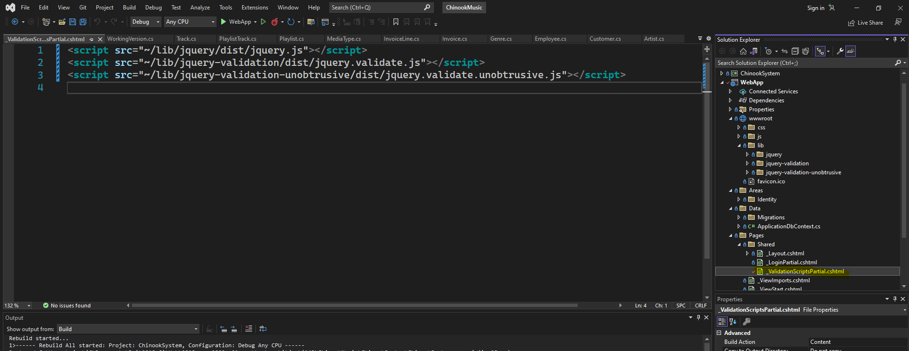

Modify the highlighted file

Import the CQRS to ViewModels

Import the service class and trx method to BLL

* Create Context Dependency
* Create queries (copy from linq)
* Create trx method (copy from linq)
  + Change table names from plural to singular
  + Add _context. In front of table names when doing query, adding a record or savechanges()

Create the form

Register trx